Weekly Agenda 9/6 – 9/9
Brit Lit and Comp – McBride
Tues. 6
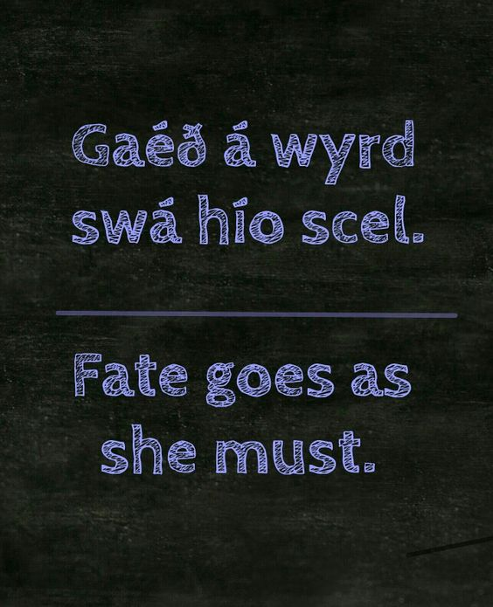
- ACT/SAT
- The Odyssey Ch. 9 and 12 Reading Check
- Cont. on our Odyssey
  - Book 21 – “Odysseus Strings his Bow”
- HW – Finish Reading Book 21
Wed. 7
- ACT WOTD/SAT QOTD
- Reading Check Book 21
- Add to IC/Journey Hero Paper.
  - Independent work/conferences
- HW - Read Book 22, Slaughter in the Hall
Thurs. 8 –
- ACT/SAT
Book 22 Reading check
- Odyssey/I.C. Carousel
- HW – TBA
Fri. 9
- ACT/SAT
- Get Lit Books
- Beginning Beowulf…
- HW – Finish Reading Part I of Beowulf.
CCSS.ELA-LITERACY.RL.11-12.1
Cite strong and thorough textual evidence to support analysis of what the text says explicitly as well as inferences drawn from the text, including determining where the text leaves matters uncertain.
CCSS.ELA-LITERACY.RL.11-12.2
Determine two or more themes or central ideas of a text and analyze their development over the course of the text, including how they interact and build on one another to produce a complex account; provide an objective summary of the text.

Weekly Agenda 9/6 – 9/9
Brit Lit and Comp – McBride
Tues. 6
- ACT/SAT
- The Odyssey Ch. 9 and 12 Reading Check
- Cont. on our Odyssey
  - Book 21 – “Odysseus Strings his Bow”
- HW – Finish Reading Book 21
Wed. 7
- ACT WOTD/SAT QOTD
- Reading Check Book 21
- Add to IC/Journey Hero Paper.
  - Independent work/conferences
- HW - Read Book 22, Slaughter in the Hall
Thurs. 8 –
- ACT/SAT
Book 22 Reading check
- Odyssey/I.C. Carousel
- HW – TBA
Fri. 9
- ACT/SAT
- Get Lit Books
- Beginning Beowulf…
- HW – Finish Reading Part I of Beowulf.
CCSS.ELA-LITERACY.RL.11-12.1
Cite strong and thorough textual evidence to support analysis of what the text says explicitly as well as inferences drawn from the text, including determining where the text leaves matters uncertain.
CCSS.ELA-LITERACY.RL.11-12.2
Determine two or more themes or central ideas of a text and analyze their development over the course of the text, including how they interact and build on one another to produce a complex account; provide an objective summary of the text.

